 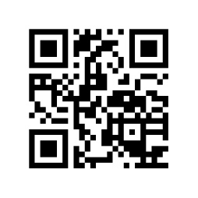

**SHORR AGENCY.com**

609 Deep Valley Drive Suite # 350 Main 1-888-737-6200 Tim@Shorr.us

Palos Verdes Peninsula, CA 90274 Fax 1-888-713-9072 CA DOI Lic # 0146520

**Statement of No Loss**

|  |  |
| --- | --- |
| Named Insured |  |
| Policy Type |  |
| Policy # |  |
| Insurance Company |  |

I certify that I am not aware of any losses, accidents or circumstances that might give rise to a claim under the insurance policy whose number is shown below, from 12:01am on:

___________________ to ________­­­­­­­­­­_______ _____:_____am/pm

(cancellation date) (today's date) (time signed)

___________________________________

Signature of Named Insured

Please return this form to Shorr Agency via email, fax or mail asap. Thank you.